

A JOLLY GOOD READ
READING TO UNDERSTAND AND ENJOY

A SATS READER TO HELP
PREPARE FOR READING COMPREHENSION
IN SATS KEY STAGE 2
Contents

Christmas in Spain 03
A Christmas Cracker! 05
The Red Crabs of Christmas Island 07

The Coral Island 10
Lord of the Flies 12
Blackbeard the Pirate 14
Peter Pan 16

Caring for your Kitten 19
‘Free Kittens’ 21

Cat-Meowing (and what it means) 23

Evacuated During the Second World War 25

Evacuees Tell their Stories 27

Earthquake Facts 29

Volcanoes 31

A Christmas Tsunami 33

Daily Life in Tudor Times 36

Tudor Punishments and Education 39

The Meadow Pipit - A Tudor Story 41

Reading Comprehension in SATS Key Stage 2 43

Guidance on Using these Texts 44




On Christmas Eve in Spain, as the stars come out, tiny oil lamps are lit that twinkle in every window. After Midnight Mass, the streets are filled with dancers. Whole families join in the Jota, a Christmas dance that has been handed down for hundreds of years, and dance to the sound of guitars and castanets. (1)
In Spain, the Three Wise Men, who brought gifts for the baby Jesus are very important. Children fill shoes with straw or barley, which they leave for the camels that carried the Wise Men to the Holy Land. The shoes are left on balconies on the night of January 6th. In the morning, the children wake up to find the straw and barley have gone. In their place are little gifts left by the Wise Men. (2)
Most homes set up a manger, complete with carved figures of the Wise Men, angels, shepherds, and of course the Holy Family. During the week before Christmas, Spanish families often gather round the manger to sing Christmas songs and hymns while children play tambourines and dance. Christmas is a deeply religious time in Spain, and it is also a time to celebrate the birth of Jesus. Christmas Eve is known as ‘Nochebuena’ or ‘the Good Night’. Families gather round the Nativity scenes to wish each other Happy Christmas, to exchange gifts, and to enjoy Christmas treats such as turron, a kind of delicious almond candy. (3)
Christmas is a deeply religious holiday in Spain. The country's patron saint is the Mary, the mother of Jesus, and the Christmas season officially begins December 8, to celebrate the occasion when the Angel Gabriel gave Mary the news that she was going to be the Mother of God’s son. . A special celebration is held each year in front of the great Gothic cathedral in Seville with a ceremony called the “Dance of Six.” Oddly, this centuries-old dance is now performed by not six but ten richly-costumed boys. The dance is quite moving and beautiful. (4)

December 28 is the Feast of the Holy Innocents, the terrible time when King Herod ordered his soldiers to kill all the new-born baby boys in Bethlehem. Fortunately, Joseph, husband of Mary, was warned in a dream, and the Holy Family was able to escape to Egypt. On this day in Spain, young boys of a town or village light bonfires, and one of them is elected Mayor for the day. This gives him the right to order grown-ups to carry out chores such as sweeping the streets, or else pay a fine which is used to pay for the celebrations. (6)
Christmas in Spain
1, When do people place oil lamps in their windows? (1 mark)
2. Why do the oil lamps remind us of little stars? (1 mark)
3. Where do people go for the service of Midnight Mass? (1 mark)
4. What is the Spanish name for the dancing in the streets? (1 mark)
5. Who take part in the Christmas street dance? (1 mark)

6. What did the Three Wise Men bring for the baby Jesus? (1 mark)
7. Why do the children fill shoes with straw and barley? (1 mark)
8. Where are the shoes left? (1 mark)
9. Where are the shoes left? (1 mark)
10. What do the children discover in the morning? (1 mark)

11. What figures are placed inside the manger? (2 marks)
12. What do many Spanish families do around the manger? (2 marks)
13. What is the Christmas treat called turron? (1 mark)
14. When does the Christmas season officially begin in Spain? (1 mark)
15. Describe what takes place during the ‘Dance of Six’? (2 marks)

16. What terrible thing happened on December 28th? (2 marks)
17. Why was the Holy Family able to escape Herod? (1 mark)
18. To where did the Holy Family escape? (1 mark)
19. How is a boy Mayor chosen in each town or village? (1 mark)
20. What can the boy Mayor do for a day? (2 marks)
A Christmas Cracker

The Christmas Party was sillier than usual, and Paul felt some satisfaction that this would be his last. In January he would be following his older brother Joe to Ancrum Road Junior School and, hopefully, there would be at least a few intelligent kids there – at Flight’s Lane Nursery there were none. (1)

Party hats (home-made), crackers (home-made), lumpy jelly (home-made), whistles, clackers, rattles, xylophones, tin drums, and out-of-tune carol singing all contributed to the racket in the over-crowded hall of the nursery. Snowballs sneaked in under pinafores had the reduced the over-waxed floor to a soggy, slippery mess; matters were not helped by the contributions of two little girls overcome by the excitement of it all. (2)

The sorry Christmas tree (seeing its third year in service) tipped over at an unlikely angle, it chocolate novelties long ripped off, and its winking bulbs reduced to five in number. Pop! Four left, thought Paul, as he tried the handle of the Quiet Room for the third time. (3)

Locked! He stamped a foot. This was outrageous. At least in the Quiet Room he could have found a bit of peace and quiet with a Wizard or a Hotspur, his favourite comics, or, even in these desperate circumstances, a Dandy or a Beano. He returned to the hall. He would demand access to the Quiet Room. Right now! To be honest, he would have already slipped out the backdoor (strictly forbidden) and down to his Gran’s, but the presents were still to come, and he was not leaving without his present. (4)

“Ho, ho, ho!” (5)

If the deep voice hadn’t given it away, the streaky moustache and the gin-tainted breath did. Santa was Matron. Santa was always Matron, head nurse at Flight’s Lane Nursery. Paul wondered why the ladies were called ‘nurses’; it wasn’t a hospital for God’s sake; as usual his questions were brushed away by ‘nurses’ too busy or not interested enough to care. So Santa was matron. It hadn’t needed Joe to tell him that. But was he the only one who recognised her? The other five-year-olds screeched in delight were only restrained by four nurses who secured her safe passage through the hall. (6)

Santa’s armchair was hauled into place. The Christmas sack hit the floor with a thud. Santa dropped her bulk into the armchair which had a bottom only a little less saggier than her own. “Ok, let’s get this over,” came Santa’s cheerful Christmas call. (7)

“Line up. Sparrows first. Then seagulls. Now you blackbirds, and then the magpies.” Nurses screamed and herded the pack into some semblance of order. Paul was five years old and therefore a magpie. In prescribed order, infants, toddlers and juniors mounted Matron, were breathed upon, exchanged whispers, and given their Christmas present. They scrambled down to be led away by nurses who then man-handled the presents from them and piled them on a table near the door to avoid disappointment, bickering, jealousy and outbreaks of fighting. (8)

Paul’s turn came. He looked up into Matron's eyes. Little black raisins embedded in a purple pudding. (9)

“Get up here, Paul.” (10)

“My mum says you have to call me Jean-Paul.” (11)

“Get up here… ‘Jean’-Paul.” (12)

“I don't answer to Jean-Paul.” (13)

“Get up here… you. Here, take it.” She thrust a small gift-wrapped parcel into his chest. (14)

“What about my Christmas wish?” (15)

Matron snorted like the walrus in the nature film they'd watched the day before and stuck her ear into his face. Paul whispered his Christmas wish. (16)

“No,” came the immediate reply. (17)

“What do you mean 'no'?” came the immediate protest. (18)

“I mean 'no'. Now go and be a normal boy for once. Go and play.” (19)

Paul stood – or sat – his ground until hauled off by Matron’s assistant, who then hauled the gift-wrapped parcel out of his hands. Silently furious, Paul stalked off across the hall. At least he would take his leave with dignity. (20)

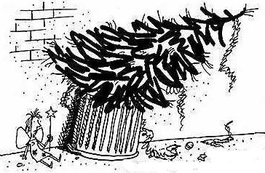
Alas, Fate, as it so often does, stepped in, as Paul stepped in a pile of jelly and slush. Across the wet, slippery floor he slid, crashing straight into the Christmas tree. Over toppled the tree, its last three bulbs popping as it landed on the sitting boy’s head. Silently, soundlessly, the Christmas tree fairy fell into his lap. (21)

A Christmas Cracker!
1. Why was this going to be Paul’s last Christmas Party at the nursery? (2 marks)
2. Why was it so noisy at the Christmas Party? (2 marks)
3. What made it a little dangerous in the hall? (1 mark)
4. What does it mean – the Christmas tree was ‘sorry’? (2 marks)
5. How do we know Paul was keen to get into the Quiet Room? (1 mark)
6. How did Paul feel when he found the Quiet Room was locked? (1 mark)
7. Why are the words ‘strictly forbidden’ placed inside brackets? (1 mark)
8. What was Paul determined to get before he left the nursery? (1 mark)
9. Why are the words “Ho, ho, ho!” given their own paragraph? (1 mark)
10. How did Paul know Santa was really the Matron? (1 mark)

11. How do we know the Matron was a large lady? (2 marks)
12. In (8) what word shows that Matron was definitely very large? (1 mark)
13. In (8) what word shows us the children did not want to give up
their presents? (1 mark)
14. What metaphor does the writer use in (9)? (1 mark)
15. How do we know that Paul and the Matron are not best friends? (2 marks)
16. What simile does the writer use in (16)? (1 mark)
17. What do you think the most important word in (19)? (1 mark)
18. Explain your answer to Question 17. (2 marks)
19. Paul wanted to leave the party with dignity.
What happened to make this impossible? (2 marks)
20. What do you think was Paul’s secret wish? (2 marks)

THE RED CRABS OF CHRISTMAS ISLAND

Christmas Island is a Territory of Australia in the Indian Ocean. The Christmas Island Red Crab is by far the most obvious of the 14 species of land crabs found on Christmas Island. It is estimated that 120 million of these bright red land crabs live in their preferred shady sites all over the island. (1)

Bright red is the common colour but there are the occasional orange specimens and more rarely some purple animals. They are a big crab. An adult body shell (or carapace) may measure up to 116mm across. Christmas Island red crabs grow slowly, reaching about 40mm in carapace width after 4-5 years. The Christmas Island red crabs moult their shells regularly during their early growth phases to match their increasing body size. Moulting usually takes place in the protected moist environment of their burrows. Mature Christmas Island red crabs probably moult only once a year, as their growth rate slows. (2)

Red Crabs diet consists mainly of fallen leaves, fruits, flowers and seedlings. They prefer fresh green leaves but will eat any fallen leaves. They are not solely vegetarian however. They will eat other dead crabs and birds, human rubbish if the opportunity presents itself. They have virtually no competition for their food resource due to their high numbers and dominance of the forest floor. (3)

Although most common in the moist environment of the rainforest, Red Crabs live in a variety of habitats including coastal shore terraces, and even domestic gardens. Tall rainforest on deeper soils has the highest crab density. They dig burrows in almost every square metre of available soil or live in deep crevices in rock outcrops. For most of the year, a crab will settle in one place, living in their burrow. The crabs' burrows have a single entrance tunnel which leads to a single chamber. Only one crab lives in a burrow and outside of the breeding season Red Crabs are solitary, and do not tolerate intruders into their burrows. (4)

At the beginning of the wet season (usually October / November), most adult Red Crabs suddenly begin a spectacular migration from the forest to the coast, to breed and release eggs into the sea. Breeding is usually synchronized island wide. The rains provide moist overcast conditions for crabs to make their long and difficult journey to the sea. The timing of the migration breeding sequence is also linked to the phases of the moon, so that eggs may be released by the female Red Crabs into the sea precisely at the turn of the high tide during the last quarter of the moon. (5)

Certain human activities have led to increased numbers of Red Crabs dying during their annual migration to the sea. Thousands of crabs are crushed by vehicles while crossing roads. Some have to negotiate up to three or four such hazards on their descent and ascent each year. Conservation measures have been implemented to help reduce this high death toll. For example, 'crab crossings' are being constructed in roads which cross main crab migration paths. Points where high numbers of Red Crabs cross roads have been identified, and tunnels are built under the road for crabs to pass through. (6)

THE RED CRABS OF CHRISTMAS ISLAND

1. In which ocean is Christmas Island located? (1 mark)
2. To which country does Christmas Island belong? (1 mark)
3. How many species of land crabs live on the island? (1 mark)
4. How many millions of red crabs live on the island? (1 mark)
5. Red crabs can also be what other colours? (2 marks)

6. What does it mean – the red crabs ‘moult’ their shells? (1 mark)
7. Why do you think the moulting takes place in their burrows? (1 mark)
8. What is the main diet of the red crab? (2 marks)
9. What else will red crabs eat? (2 marks)
10. Explain why red crabs do not have much competition for food? (1 mark)

11. Apart from the rainforest, where else do red crabs live? (2 marks)
12. Why do you think red crabs make only one entrance to their homes? (2 marks)
13. Do red crabs live on their own or in groups? (1 mark)
14. Why do the crabs make for the coast during the wet season? (1 mark)
15, Do they all travel to the coast at the same or different times? (1 mark)

16. Why is the Moon so important at breeding time? (1 mark)
17. What happens to thousands of red crabs on their way to the sea? (1 mark)
18. What are ‘crab crossings’? (1 mark)
19. Explain how the ‘crab crossings’ work. (1 mark)
20. In our opinion, is it important that we help the red crabs survive?
Give reasons for your opinion. (3 marks)
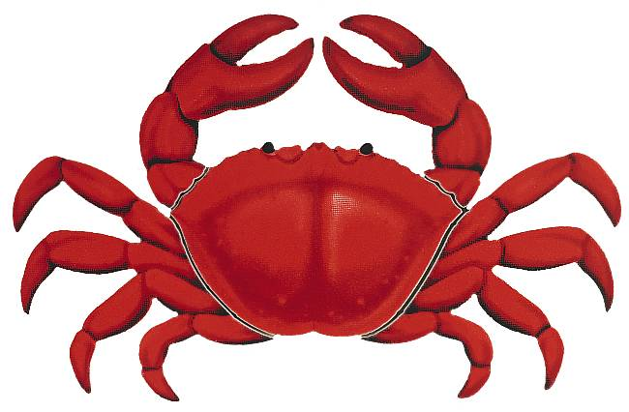

THE CORAL ISLAND
R. M. Ballantyne

Three boys, Ralph (the narrator), Jack and Peterkin, are the sole survivors of a shipwreck on the coral reef of a large but uninhabited Polynesian island. At first their life on the island is perfect; food, in the shape of fruits, fish and wild pigs, is plentiful, and using their only possessions; a broken telescope, an iron-bound oar and a small axe, they fashion a shelter and even construct a small boat. Their first contact with other people comes after several months when they observe……. (1)

“A sail! a sail! Ralph, Jack, look! Away on the horizon there, just by the entrance to the lagoon!” cried Peterkin, as we scrambled up the rocks. “So it is, and a schooner, too!” said Jack, as he proceeded hastily to scramble into the rags of our clothing. (2)

Our hearts were thrown into a terrible flutter by this discovery, for if it should touch at our island we had no doubt the captain would be happy to give us a passage to some of the civilized islands, where we could find a ship sailing for England, or some other part of Europe, from where we could easily make out way home. With joyful anticipations we hastened to the highest point of rock near our dwelling, and awaited the arrival of the vessel, for we now perceived that she was making straight for the island, under a steady breeze. (3)

In less than an hour she was close to the reef, where she rounded to, and backed her topsails in order to survey the coast. Seeing this, and fearing that they might not perceive us, we all three waved pieces of cocoa-nut cloth in the air, and soon had the satisfaction of seeing them beginning to lower a boat and bustle about the decks as if they meant to land. Suddenly a flag was run up to the peak, a little cloud of white smoke rose from the schooner's side, and, before we could guess their intentions, a cannon-shot came crashing through the bushes, carried away several cocoa-nut trees in its passage, and burst in atoms against the cliff a few yards below the spot on which we stood. (4)

With feelings of terror we now observed that the flag at the schooner's peak was black, with a Death's head and cross bones upon it. As we gazed at each other in blank amazement, the word “pirate” escaped our lips simultaneously. (5)

“What is to be done?” cried Peterkin, as we observed a boat shoot from the vessel's side, and make for the entrance of the reef. “If they take us off the island, it will either be to throw us overboard for sport, or to make pirates of us.” (6)

I did not reply, but looked at Jack, as being our only resource in this emergency. He stood with folded arms, and his eyes fixed with a grave, anxious expression on the ground. “There is but one hope,” said he, turning with a sad expression of countenance to Peterkin; “perhaps, after all, we may not have to resort to it. If these villains are anxious to take us, they will soon overrun the whole island. But come, follow me.” (7)

Stopping abruptly in his speech, Jack bounded into the woods, and led us by a circuitous route to Spouting Cliff. Here he halted, and, advancing cautiously to the rocks, glanced over their edge. We were soon by his side, and saw the boat, which was crowded with armed men, just touching the shore. In an instant the crew landed, formed line, and rushed up to our shelter. Now, boys, we have but one chance left,--the Diamond Cave.” (8)

We spent an anxious but quite comfortable night in the cave since we’d left food supplies there for just such an emergency as this. In the morning, I woke first and determined to discover what was up with our unexpected and undesirable ‘guests’. I did not wake my friends, knowing they would do their best to dissuade me from taking such a risk. So leaving them soundly sleeping, out of the cave and off to the beach I crept. (9)

Standing on the warm, golden sand, I was thrilled and relieved to see no sign of the pirates’ schooner. I scanned the horizon for a full minute, then gave vent to a deep sigh of relief: “Yes, they’ve gone. Those villains have been deprived of their prey this time.” (10)

“Don’t be sure of that, puppy!” said a deep voice at my side; while, at the same moment, a heavy hand grasped my shoulder, and held it as if in a vice. (11)

1. What do the boys live on while they are on the island? (1) 3 marks
2. What do you think is their most useful tool? Why? (1) 2 marks
3. How long is it before they see other people? (1) 1 mark
4. Who spots the sail on the horizon? (2) 1 mark
5. What type of vessel do the boys see? (2) 1 mark

6. Why are the boys so excited to see a ship? (3) 2 marks
7. Why did the boys climb to the highest point of a rock? (3) 1 mark
8. How did the boys try to attract the ship’s attention? (4) 1 mark
9. How do you think the boys felt when they saw it was a pirate ship? (5) 2 marks
10 What did Peterkin think would happen if they were captured? (6) 2 marks

11 Why do you think Peterkin and Ralph turned to Jack? (7) 1 mark
12 How did the pirates know the island was inhabited? (8) 1 mark
13 Why had the boys left food supplies in the Diamond Cave? (9) 1 mark
14 Why didn’t Ralph wake up his friends before he left the cave? (9) 1 mark
15 Ralph thought the pirates had sailed away. Why was he wrong? (11) 1 mark

LORD OF THE FLIES
William Golding

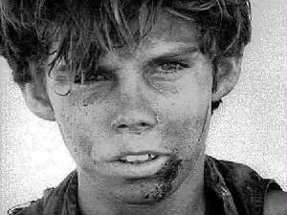
A group of English schoolboys, evacuated from a war situation, find themselves on a small tropical island after their plane is shot down. There are no adult survivors. They elect Ralph as their chief, despite the claims of Jack Merridew, the head choir boy, to be leader. The boys have a meeting to decide what they should do and agree to make a signal fire on top of the mountain to attract passing ships. (1)

After some weeks it is clear that Ralph and Jack have different priorities; Ralph tries to build shelters and keep a fire going that has been lit with the help of Piggy’s glasses, whilst Jack hunts for pigs. Meanwhile, some boys are scared of a ‘beast’ they believe is on the Island. While Jack and the hunters are off hunting, a ship is seen on the horizon, but the signal fire on the mountain has gone out. (2)

“All right, all right!” said Jack, looking at Piggy, Ralph and the other boys. “I know my hunters and I promised to keep the fire going, but we need meat. He repeated the word and was rewarded with a murmur of approval from the hunters. (3)
“But it was a ship,” said Jack. “A ship! We could have been rescued. We could have been on our way home.” This time it was Ralph who received the murmurs of approval. (4)
“Home,” repeated Piggy. “You and your stupid meat,” said Piggy. “That’s all you think about, Jack Merridew.” (5)
Jack seized the opportunity. “You shut up,” he snarled at Piggy, and so malevolent was the note in his voice that Piggy lowered his eyes to the ground and stared at his feet. (6)

Once again Jack turned to Ralph. “I'm sorry. About the fire, I mean. There. I….” He paused for a few moments. Then… “I apologise.” (7)
The buzz from the hunters was one of admiration at this handsome behaviour. Clearly they were of the opinion that Jack had done the right thing, had put himself in the right by his generous apology and Ralph, somehow or other, was in the wrong. They waited for an appropriately decent response. (8)
Yet Ralph's throat refused to pass one. He resented, as an addition to Jack's misbehaviour, this verbal trick. The fire was dead, the ship was gone. Could they not see? Anger instead of decency passed his throat. (9)
“That was a dirty trick.” (10)
They were silent on the mountain-top while storm clouds appeared in Jack's eyes and passed away. Ralph's final word was an ungracious mutter. “All right. Light the fire.” (11)

Questions

1. Why were the boys evacuated from England? (1) 2 marks
2. How many grown-ups survive the plane crash? (1) 1 mark
3. How does Ralph become chief? (1) 1 mark
4. Who thought he should be chief instead of Ralph? (1) 1 mark
5. Why do the boys agree to build a signal fire? (1) 2 marks
6. How are the boys able to start a fire? (2) 1 mark
7. What is the most important thing for Jack? Why? (2) 2 marks
8. Why do some of the boys become frightened? (2) 1 mark
9. Why does a passing ship fail to check out the island? (2) 1 mark
10 Who was responsible for keeping the signal fire alight? (2) 1 mark

11 Why did Jack repeat the word ‘meat’? (3) 1 mark
12 Did Jack’s hunters agree that finding meat was essential? (3) 1 mark
13 Why did Ralph say the signal fire was so important? (4) 1 mark
14 Why do you think the hunters now agreed with Ralph? (4) 1 mark
15 How did Piggy make Jack so furious? (5) 1 mark
16 How did Jack silence Piggy? (6) 1 mark
17 What did Jack do that put Ralph on the wrong foot? (7) 1 mark
18 What did Ralph mean by ‘That was a dirty trick.’ (10) 2 marks
19 What were the ‘storm clouds’ that appeared in Jack’s eyes? (11) 1 mark
20 Why do you think Ralph said: “All right. Light the fire.” (11) 1 mark

BLACKBEARD THE PIRATE


Edward Teach, better known as ‘Blackbeard’, was the most feared pirate of his time. He sailed the Caribbean Sea during what is called the ‘Golden Age of Piracy’, which lasted roughly from 1700 to 1725. Blackbeard was a skilled sailor and businessman, who knew how to recruit and keep good sailors, intimidate his enemies, and use his fearsome reputation to his best advantage. Blackbeard preferred to avoid fighting, if he could, but he and his men were deadly fighters when they were forced to fight. (1)

Little is known about Edward Teach’s early life, but it is believed he was born in Bristol around 1680. Like many young men of Bristol – one of England’s biggest ports – he took to the sea as a boy of around 13 years. As he grew up, he saw plenty of fighting during Queen Anne’s War (1702-1713). However, though he was a very able seaman, he was passed over several times for promotion, and this may have made him feel rather bitter. (2)

Sometime between August and October of 1717, Teach managed to secure his own vessel. This was the Revenge which Teach fitted out as a pirate hunter, but the minute he was out of port, he hoisted the Skull and Crossbones and was off in search of rich prey – merchant ships that were carrying gold, silver, sugar and coffee from the New World to Europe. Before long, Teach had a fleet of three ships and 150 pirates under his command. He also gave himself the name of ‘Blackbeard’ – a name that came to be feared on both sides of the Atlantic and across the Caribbean. (3)

Blackbeard was much more intelligent than your average pirate. He preferred to avoid fighting if he could, and so cultivated a very fearsome reputation. He wore his hair long and had a long black beard. He was tall and broad-shouldered. During battle, he put lengths of slow-burning fuse in his beard and hair. This would sputter and smoke, giving him an altogether demonic look. He also dressed the part: wearing a fur cap or wide hat, high leather boots and a long black coat. He also wore a modified sling with six pistols into combat. No one who ever saw him in action forgot it, and soon Blackbeard had an air of supernatural terror about him. (4)

Blackbeard used fear and intimidation to cause his enemies to surrender without a fight. This was in his best interests, as the victimized ships could be utilized, valuable plunder was not lost and useful men such as carpenters or doctors could be made to join the pirate crew. Generally, if any ship they attacked surrendered peacefully, Blackbeard would loot it and let it go on its way, or put the men aboard some other ship if he decided to keep or sink his victim. There were exceptions, of course: English merchant ships were sometimes treated harshly, as was any ship from Boston, where some pirates had recently been hung. (5)

Finally, however, the British government had had enough of Blackbeard and sent ships from the Royal Navy after him. On November 22, 1718, they caught up with him, and, fortunately for them, many of Blackbeard’s men were on shore collecting barrels of fresh water. (6)

Soon there was desperate fighting on Blackbeard’s ship as the marines and pirates fought hand to hand. The English captain, Maynard, managed to wound Blackbeard twice with pistols, but the mighty pirate fought on, his cutlass in his hand. Just as Blackbeard was about to kill the captain, a soldier rushed in and cut the pirate across the neck. The next blow took off Blackbeard's head. Maynard later reported that Blackbeard had been shot no fewer than five times and had received at least twenty serious sword cuts. Their leader gone, the surviving pirates surrendered. Maynard returned victorious to Virginia with Blackbeard's head displayed on the bowsprit of his ship. (7)

Blackbeard's fame lingered long after he was gone. Men who had sailed with him automatically found positions of honour and authority on any other pirate vessel they joined. His legend grew with every retelling: according to some stories, his headless body swam around Maynard's ship several times after it was thrown into the water following the last battle! (8)

Blackbeard has been the subject of several movies, plays and books. Despite little solid evidence, legends persist of Blackbeard's buried treasure, and people still search for it. The wreck of the Revenge was discovered in 1996. (9)

1. What was Blackbeard’s real name? (1) 1 mark
2. For how many years did the ‘Golden Age of Piracy’ last? (1) 1 mark
3. What does it mean that Blackbeard could ‘intimidate’ his enemies? (1) 2 marks
4. Why did many young men from Bristol become sailors? (2) 2 marks
5. Why did Teach become bitter about being in the navy? (2) 1 mark

6. What was the Skull and Cross Bones? (3) 1 mark
7. What kind of ‘treasure’ did Blackbeard seize from merchant ships? 1 mark
8. Explain why Blackbeard dressed so strangely before a fight? (4) 2 marks
9. What kind of men were sometimes forced to become pirates? (5) 2 marks
10 Why did Blackbeard treated ships from Boston harshly? (5) 1 mark

11 Why was the Royal Navy lucky when they caught up on Blackbeard? (6) 2 marks
12 Explain how Captain Maynard’s life was saved? (7) 2 marks
13 Describe one of the legends that grew up about Blackbeard? (8) 2 marks
14 Do you think there’s a chance that Blackbeard’s treasure can be found? (9) 2 marks
15 Why do you think Blackbeard’s reputation has lasted so long? (9) 2 marks

PETER PAN
JM Barrie

It might be difficult to find any child anywhere in the world who has never heard of Peter Pan, the only boy in all the world who never grows up. Peter Pan spends his never-ending childhood having adventures on the small island of Neverland where he leads his gang, the Lost Boys in a world of mermaids, Indians, fairies, pirates, and occasionally ordinary children from the world outside. (1)

In this extract Peter finally comes face to face with his arch-enemy, Captain James Hook, and, as Peter says “It’s you or me this time.” (2)

HOOK OR ME THIS TIME

Suddenly Hook found himself face to face with Peter. The others drew back and formed a ring around them. For long the two enemies look at one another, Hook shuddering slightly, and Peter with a strange smile on his face. (3)
“So, Pan,” said Hook at last, “this is all your doing.” (4)
“Ay, James Hook,” came the stern answer, “it is all my doing.” (5)
“Proud and insolent youth,” said Hook, “prepare to meet thy doom.” (6)
“Dark and sinister man,” Peter answered, “have at thee.” (7)
Without more words they fell to, and for a space there was no advantage to either blade. Peter was a superb swordsman, and parried with dazzling rapidity; ever and anon he followed up a feint with a lunge that got past his foe's defence, but his shorter reach stood him in ill stead, and he could not drive the steel home. (8)
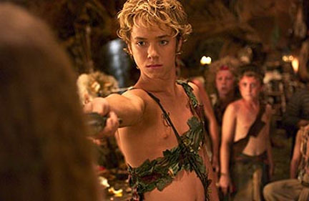

Then he sought to close in and finish Peter off with his iron hook, which all this time had been pawing the air; but Peter doubled under it and, lunging fiercely, pierced him in the ribs. At the sight of his own blood, whose peculiar colour, you remember, was offensive to him, the sword fell from Hook's hand, and he was at Peter's mercy. (9))
“Now!” cried all the boys, but with a magnificent gesture Peter invited his opponent to pick up his sword. Hook did so instantly, but with a tragic feeling that Peter was showing good form. Hook was fighting now without hope, but there was one thing left he could do – he, James Hook, was a gentleman, but before he went into the cold and dark he would show that Peter Pan was not! (10))
Abandoning the fight he rushed into the powder magazine and fired it. “In two minutes,” he cried, “the ship will be blown to pieces.” (11)
“Now I shall show that Peter Pan is a coward,” he thought. But calmly Peter picked up the powder barrel, shook it by his ear, and just as calmly through it over the side of the ship where it exploded with a tremendous Bang! (12)
It was almost all over for Captain Hook, and he knew it. The boys danced around him, teasing him, taunting him, the youngest even daring to stick out their tongues at him. O, the shame of it! (13)
Backwards, always backwards, staggered Hook until he was the farthest end of the gangplank where so many had been forced to fall into the sea. And, seeing the boy advance towards him along the plank, he turned ready to let himself fall into the sea. (14)
But wait! We must not let Captain James Hook die such an ignoble death. He has been a grand enemy for the boy, so we shall allow him one last triumph. The man reaches the end of the gangplank. He turns his back on the boy and bends over to look into the deep blue sea. And Peter, quite forgetting his manners, boots him up the backside. And down goes James Hook, down, down, into the jaws of the crocodile who has paddled patiently around waiting for this delicious moment. (15)
“Farewell, you rude boy,” he smiles, as he disappears content at last. (16)

1. What is unique about Peter Pan? (1) 1 mark
2. Why did the boys form a ring around Hook and Peter? (1) 1 mark
3. What does Peter mean: “It’s you or me this time.” ? (2) 1 mark
4. What disadvantage did Peter have in the duel? (8) 2 marks
5. How did Hook try to end fight? (9) 2 marks
6. What shock did Hook suddenly get? (9) 2 marks
7. How did Peter show he always played fair? (10) 2 marks
8. What did Hook want to show before Peter finished him off? (10) 2 marks
9. Why do you think Hook tried to blow up the whole ship? (11) 2 marks
10 How did Peter react to the danger? (12) 1 mark
11 Why did Hook begin to feel ashamed? (13) 2 marks
12 What did Hook prepare to do? (14) 1 mark
13 Why does the writer say “Wait!” (15) 2 marks
14 How does Peter forget his manners? (15) 1 mark
15 Why is Captain James Hook ‘content’ at last? (16) 2 marks

For discussion: If you were JM Barrie would you have spared Hook’s life
and let him live to fight another day.

Quotations from JM Barrie
“Dreams do come true, if only we wish hard enough. You can have anything in life if you will sacrifice everything else for it.”
“If growing up means it would be beneath my dignity to climb a tree, I'll never grow up, never grow up, never grow up! Not me!”
“Those who bring sunshine to the lives of others cannot keep it from themselves.”
“Shall we make a new rule of life from tonight: always try to be a little kinder than is necessary?”
“If you cannot teach me to fly, teach me to sing.”

“Oh, the cleverness of me!”
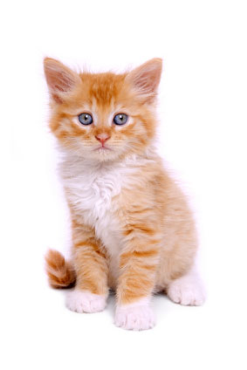
CARING FOR YOUR KITTEN
Bringing the kitten home

Moving to a new home is very stressful for a kitten. Give it reassurance and time to adjust to the new surroundings before making introductions to any other animals in the household. Make sure all the doors and windows are closed and that there is a guard in front of the fireplace (a dark, quiet chimney can be very inviting to a nervous kitten). Make sure that the kitten knows where the bed, litter tray and food bowls are. (1)
The kitten’s bed should be a refuge to retreat to if things become too stressful. It needs to be warm, dry, comfortable and draught free. There are many types of bed to choose from or you can put some warm bedding inside a strong dry cardboard box with a hole cut in the side. Putting it in a warm secure corner (near a radiator in the winter) will make it welcoming and the kitten feel secure. On the first few nights a warm water bottle under a blanket may help to compensate for the absence of the kitten's mother or littermates. (2)
Introducing other pets and children

Introduction to other household residents should be gradual, gentle and very quiet. Excited children can easily injure a kitten unintentionally so always supervise play and do not allow the kitten to be picked up unnecessarily. Children should be encouraged to sit on the floor and wait for the kitten to explore them. Make sure that the kitten is allowed to stop playing when it wants to and is not treated like a toy. Kittens, like many young animals, will need a lot of sleep and should be allowed time to rest. (3)
Introducing a kitten to a dog or cat needs to be undertaken carefully to avoid conflict. A bad experience can be difficult to overcome. If you have a large mesh pen in which the kitten can sit safely while the resident cat or dog can gradually get used to it, this is an ideal way to make introductions. Some dogs, especially those not used to cats or of an excitable or aggressive disposition, need extra special care for introductions. They should be kept as calm as possible on the lead and made to sit quietly. The new kitten should be given a safe position in the room and allowed to get used to the dog and approach if it wants. This may take quite some time and requires patience and rewards for the dog if it behaves well. (4)
When you first take a kitten home feed it on the same food it has been used to. A sudden change of diet combined with the stress of adapting to a new home can cause stomach upsets and diarrhoea. If you want to change the diet, do so gradually by mixing it with the kitten's usual food. Kittens have very small stomachs and have to be fed little and often, like babies. (5)

There are foods which have been specially formulated for kittens because they have different nutritional needs to the fully grown cat. Read and follow the feeding instructions carefully. If the food is marked 'complete' it contains everything the kitten needs to stay healthy. If it is marked 'complementary' it does not supply all the kitten needs and should be fed with other foods. (6)
Do not give your kitten cow's milk as it can cause diarrhoea. If you wish to feed milk use one that is specially formulated for cats. Diarrhoea that persists for more than 24 hours requires veterinary attention. Fresh drinking water should be available at all times. (7)
Going outside

Your kitten should not be allowed outside until at least a week after it has finished its first course of vaccinations at about 13 - 14 weeks old (depending on the vaccine). Once it is fully vaccinated and has become used to life in your house, you can start to let your kitten go outside. Choose a dry day (if possible) and a quiet time and accompany your kitten outside, allowing it to explore the new environment. Continue to accompany the kitten until it is used to your garden and can find its way back to the house without difficulty. It is best not to leave your kitten outside alone until it is 6 months old. (8)

1. Explain three things you should do to help a kitten settle into its new home? (1) (3)
2. Why might a kitten feel a little lost and lonely when settling in? (2) (2)
3. Why should children be supervised when they’re playing with a kitten? (3) (2)
4. What does the writer mean – a kitten should ‘not be treated like a toy’? (3) (2)
5. How should a kitten be introduced to other animals in the house? (4) (3)
6. How and why should kitten be fed like (human) babies? (5) (2)
7. Explain the difference between ‘complete’ and ‘complementary’ food. (6) (2)
8. What should kittens not be fed cow’s milk? (7) (1)
9. Why do you think a kitten needs a course of vaccinations? (8) (1)
10. Describe how you should get a kitten used to playing outside? (8) (3)

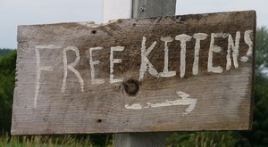
‘FREE KITTENS’
Jim Willis

The sign was hand-lettered and read “FREE KITTENS.” It appeared there two or three times a year, sometimes spelled this way, sometimes that, but the message was always the same. (1)
In a corner of the farmhouse back porch was a torn cardboard box with a dirty towel inside, on which huddled a handful of kittens of different colors, mewing and blinking and waiting for their mama to return from hunting in the fields. The mother cat managed to show them enough interest for the first few weeks, but after having two or three litters per year, she was worn out and her milk barely lasted long enough for her babies to survive. (2)
One by one, people showed up over the next several days and each took a kitten. Before they left the farmer’s wife always said the same thing, “You make sure you give that one a good home - I've become very attached to that one.” (3)
One by one the kittens and their new people drove down the long driveway and past the sign on the mailbox post, “FREE KITTENS.” (4)
The ginger girl kitten was the first to be picked. Her four-year-old owner loved her very much, but the little boy accidentally injured the kitten's shoulder by picking her up the wrong way, tossing her up in the air and catching her. Although the kitten meowed piteously, the boy thought she was enjoying the game and continued it for ages. The boy couldn't be blamed really - no adult had shown him the proper way to handle a kitten. He had named the kitten “Ginger” and was very sad a few weeks later when his older brother and his friends were playing ‘Chase’ in the living room and one of them sat on the kitten. (5)
The solid white boy kitten with blue eyes was the next to leave with a couple by the name of Gantry. Even before they got into their car, they announced the kitten’s name would be ‘Snowball.’ Unfortunately, he never learned his name. After the first few days, the couple got bored with him and paid him so little attention they failed to realise Snowball was deaf. On his first excursion outside he was run over in the driveway and buried under a rosebush. (6)
Snowball’s brother, a beautiful red tabby, was more fortunate being ‘adopted’ by an elderly lady named Jemima. So thrilled was she by the handsome little fellow that she immediately took ‘Erik’ round to visit all her neighbours. Though terrified by some of the cats and dogs he met, Erik was treated like a little prince. Sadly his good fortunate did not last, for Jemima had ignored the need to have him vaccinated – “but he looked so health and happy,” she explained. Unable to meet the expenses of having Erik treated by the local vet., she allowed Nature to take its course, and Erik passed away in his sleep. (7)
The pitch-black male kitten grew up to be a fine example of a tomcat. However, the man who’d purchased him and named him ‘Killer’ moved home after a year and abandoned Killer to his own devices. The tomcat spent a few happy (more-or-less) months roaming the neighbourhood, slaughtering small birds and defending his territory until one day he was cornered by another ‘Killer’ – a Rottweiler who lived up to his name. To his credit, Killer (the cat) put up a fierce fight until the inevitable. (8)
A pretty woman, Bella by name, driving a white van, took the last two kittens, a gray boy and a brown tiger-striped girl. She promised they would always stay together. She sold them for fifteen pounds each to a laboratory. To this day, they are still together...in a jar of alcohol. (9)
For whatever reason - because Heaven is in a different time zone, or because not even cat souls can be trusted to travel in a straight line without meandering - all the kittens arrived at Heaven's Gate simultaneously. They batted and licked each other in glee, romped for awhile, and then solemnly marched through the gate, right past a sign lettered in gold:
"YOU ARE FINALLY FREE, KITTENS." (10)

1. What did the sign at the farm mean? (1) (1)

2. What evidence tells us the kittens were not well cared for? (2) (3)

3. The farmer’s wife claims she really loved every kitten?

Explain why you might find this hard to believe? (3) (2)

4. Do you think the four-year-old boy is to blamed for what happened

to the kitten he named ‘Ginger’. Give reasons for your opinion. (5) (3)

5. How does what happened to ‘Snowball’ make you feel? Give your reasons. (6) (3)

6. What mistake did Jemima make in looking after Erik? (7) (2)

7. In what way did ‘Killer’, the Rottweiler’ ‘live up to his name’? (8) (2)

8. How did Bella show she was dishonest in her treatment of the last two kittens? (9) (2)

9. How did the kittens feel when they were reunited in Heaven? (10) (2)

10. What do you think this story is trying to tell us? Do you think it does this well? (3)
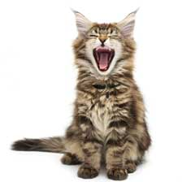

Cat-Meowing (and what it means)
Cats do most of their meowing when they want something but they do occasionally meow to say hello. However, there may be times when a cat starts meowing more or less constantly, and that can be quite a headache as much for you as for the cat. Most cats who constantly meow are doing so because they're trying to tell you something. Please bear in mind that your cat doesn't meow just to annoy you and the quicker you can figure out the reasons for the noise, the quicker it will stop. Try some of these. (1)
Firstly, make sure that your cat isn't meowing due to an illness or medical problem. Cats do meow to communicate, not just to demand things, so illness should be ruled out first of all. If there’s no sign of illness, check these out. (2)
- Feed on a regular basis. Try feeding your cat at set times/regular intervals so they can anticipate when they're next going to eat. You can also try leaving down the dry cat food/biscuits so that your cat can nibble whenever they get hungry. However, if your cat has a tendency to over-eat, this may not be wise. (3)

- Install a cat flap. Most cats can never make up their minds if they want to be in or outside. My cat is in heaven during the summer when I can leave the back door open and he can wander in and out at much as he pleases. If your cat is always in and out, a cat flap is a great option. They're fairly cheap and easy to install and you buy ones which have magnets on them so only YOUR cat can get in; otherwise you can be sure of lots of unwelcome visitors. (4)

- Play. Some cats meow a lot because they want some attention and affection. Stroke and play with your cat often to keep them from feeling lonely or neglected. A bored cat is not a happy cat. (5)

- Discipline. Don't let your cat drive you round the bend with excessive meowing - take charge. You can either ignore them which will eventually make them stop if you don't give in (very hard to do!) or you can try the old favourites of a squirt with a water spray or a firm 'NO' and a clap of the hands. Eventually your kitty will realise that constant meowing will get them nowhere. Please ensure you remember to praise your cat and give extra attention to them when they're not meowing. (6)

- Try asking. And, if all else fails, try asking him what’s up. (7)

1. What is the main reason a cat may start meowing? (1) (1)
2. What other reason can there be for a cat to meow? (1) (1)
3. Why should you try to understand why your cat is meowing? (1) (2)
4. What is the first thing to try and discover if your cat is meowing all the time? (2) (1)
5. Why does a cat appreciate being fed at regular intervals? (3) (1)
6. What kind of cats should not be provided with ‘nibbles’? Why not? (3) (2)
7. Why does most cats love having a cat-flap? (4) (1)
8. Explain one advantage and one disadvantage of providing a cat-flap? (4) (2)
9. Why might a cat feel lonely and neglected? (5) (2)
10. What three ways of stopping a cat meowing too much are described in (6)? (3)
11. Why should you ‘reward’ your cat when he is not meowing all the time? (6) (2)
12. The writer advises asking your cat ‘what’s up?’ if nothing else works.
How serious do you think the writer is? Explain your answer? (7) (3)

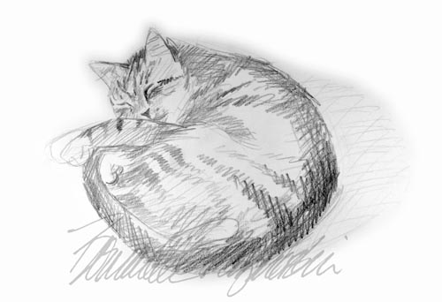

EVACUATED DURING THE SECOND WORLD WAR

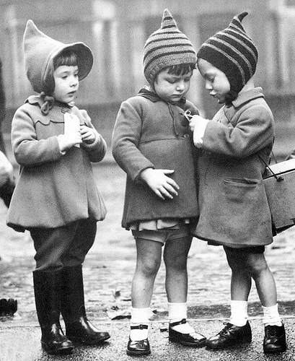
HOW IT BEGAN

For hundreds of thousands of families the Second World War began, not with the blackout at sunset on Friday 1st September, but shortly before sunrise. The start of evacuation had been announced on the radio the day before, and in the residential streets of the great cities, soon after dawn, mothers were packing into suitcases the garments lovingly cleaned and pressed over the previous few days. That Friday morning, in an equal number of other homes in quieter parts of the country, other women, almost as deeply moved, were beginning their very different preparations, dusting out the spare room or looking out their own children’s discarded toys. (1)

The government had decided that evacuation should be voluntary but that billeting (giving children a home) should, if necessary, be compulsory. Although few people wanted to accommodate adults, there was, in 1939, little difficulty in finding foster-homes for children. (2)

Many schools had been assembling the children every morning for the past week to keep them together, and one helper at a North London infant and junior school believes she will never get out of her ears the chorus of Ten Green Bottles, sung by hundreds of five-to twelve-year-olds as they sat on the floor of the school hall during these days of waiting. The departure when it actually came was, by universal agreement, a model of efficiency. Usually the children were mustered in the playground, parents being asked to stay outside, then each school set off for the station led by a ‘marked man’, often the caretaker, carrying a placard giving its name and reference number. (3)

The hardest burden of all that day fell on the parents and many comforted themselves with small details, like the fact that their daughter looked proud of her new gas mask case, or their son seemed thrilled to have secured a seat nearest the window of the train. A teacher who escorted the children remembers one six-year-old girl innocently asking, ‘Why are some mummies crying?’, and being satisfied with the explanation, ‘Because they can’t come on holiday with us.’ Teachers were often more apprehensive than the children, for none, apart from schools which had made their own arrangements in advance, knew where they were going until they arrived. (4)
Many people still have bitter memories of the ‘slave market’, at which they were allocated to foster-parents – in one Lincolnshire town the cattle market was actually used as a distribution centre. At least the ‘market’ method avoided the sad trudge from door to door in search of a welcoming home. (5)

Some children, however, took time to settle in as we can see from these two postcards that survived the War. ‘Dear Mam, I want to come home. Pleas come and tack us home’, reads card, duly delivered next morning to a Liverpool mother. Only the postmark enlightened Mam as to her children’s whereabouts. The writer had forgotten to include his address. ‘Dear Mum, I hope you are well’, ran another card. ‘I don’t like the man’s face. I don’t like the lady’s face much. Perhaps it will look better in daylight. I like the dog’s face best.’ (6)

Placings with unmarried women were often surprisingly successful. At Combe Raleigh, Devon, one billeting officer placed, with some misgivings, a three-year-old toddler with three elderly maiden ladies. On arrival he stood solemnly gazing round at his new home with tears pouring down his cheeks and announced: ‘My name is Robert; I am a big boy and I don’t cry – well, not often.’ Within a few months he was idolised by the whole household and when his mother eventually came to see him she was horrified when at bedtime he knelt down and prayed: ‘O God, don’t let this woman take me away; she says she’s my mother, but I want to stay here with my aunties.’ (7)

For the vast majority of children evacuation was a positive experience The nation’s mothers revealed on the 1st September 1939, and the days immediately following it, a warmth and good nature towards other people’s children that many of their guests still recall with affection nearly thirty years later. (8)

Questions

1. What did many mothers start doing early on 1st September 1939? (1) 1 mark
2. How did people learn about the start of the evacuation? (1) 1 mark
3. What were women in quieter parts of the country doing? (1) 2 marks
4. Did families have to agree to children being evacuated? (2) 1 mark
5. Why do you think most families agreed with evacuation? (2) 2 marks

6. Why do you think most people were happy to billet children (2) 2 marks
7. Why do you think most schools held an assembly every morning? (3) 1 mark
8. What does it mean – the departure was a ‘model of efficiency’? (3) 1 mark
9. What was the job of the ‘marked man’? (3) 1 mark
10 Why do you think evacuation day was most difficult for the parents? (4) 2 marks

11 Why do you think the children were the least worried on evacuation day? (4) 2 marks
12 What happened at the ‘slave market’? (5) 1 mark
13 What was one advantage of the ‘slave market’ system? (5) 1 mark
14 How did children send news of their arrival back home? (6) 1 mark
15 Why do you think Robert turned out to be lucky? (7) 2 marks

16 Why do you think Robert’s mother got a shock when she visited him? (7) 1 mark
17 What did the evacuation show about the mothers of this country? (8) 1 mark
18 How would you react if you were told you were going to be evacuated? 2 marks

EVACUEES TELL THEIR STORIES

Our train pulled into a station in the middle of nowhere about midnight. Most of us were sound asleep but they roused us like we were soldiers going to war. We stumbled into the streets and were herded around like sheep and cows. Officials knocked on the doors of people who’d put their names down as being willing to take an evacuee. That person would come out of his house and choose a kid he liked the look of. It was total chaos. Some children were still being walked around the street a couple of hours later. I know because I was one of them. Eventually Mr. and Mrs. Jackson took pity on me even though they couldn’t understand much of what I was saying, being as I’m from Liverpool. It turned out I was lucky. Mr. Jackson was the local grocer, so I ate really well right through the War. Billy Miles, 13, when evacuated

Mrs. Brown was very strict and extremely house-proud so I had to watch my step. However, she was a wonderful cook. Mr. Brown (Ronald) was a farmer, a churchwarden, a member of the Royal Observer Corp and a very respected member of the community and I loved him from the start. He had the most wonderful giggle and when the two of us started it drove everybody mad. We always had a lot of fun together. My own father had always been very distant with me and I can never remember him giving me a cuddle or sitting on his knee. Whereas Mr. Brown was entirely opposite, so I suppose it was only natural that I came to regard him as my true dad in every sense. Rosie, 8, when evacuated

I had only been with the Smiths for three days when I woke up and found my body was covered in spots and blisters. I'd caught chickenpox. As it was Christmas Eve, this meant we could not spend the festive holiday with Smith's parents, which was the usual custom, as I was confined to my bed. As Mr. Smith was so determined that I should be kept amused he climbed up into the loft and brought down his mandolin which he had brought back from Greece at the end of the First World War (and incidentally never played since) and tried to keep me happy by playing lots of tunes (not too well I'm afraid). Even though I was feeling pretty ill, I can tell you we had plenty of laughs. (3) Margaret Webb, 9, when evacuated

Questions

1. How does Billy make it clear the arrival was ‘total chaos’? 2 marks
2. How do we know Billy was totally exhausted by the time he found a home? 2 marks
3. Why did Billy turn out to be really lucky? 2 marks
4. Why did Rosie like Mr. Brown better than Mrs. Brown? 2 marks
5. What was the main difference between Mr. Brown and Rosie’s father? 2 marks
6. Why was Margaret really unlucky? 2 marks
7. How did Mr. Smith try to keep Margaret’s spirits up? 2 marks
8. Taking the three diary entries together, do you think most children
had a positive experience about evacuation? Give your reasons. 2 marks
9. In your opinion, do you think boys or girls found it easier
to be evacuated? Give your reasons. 2 marks
10 If you were a family accepting an evacuee, would you choose
a girl or a boy as your evacuee? Give your reasons. 2 marks
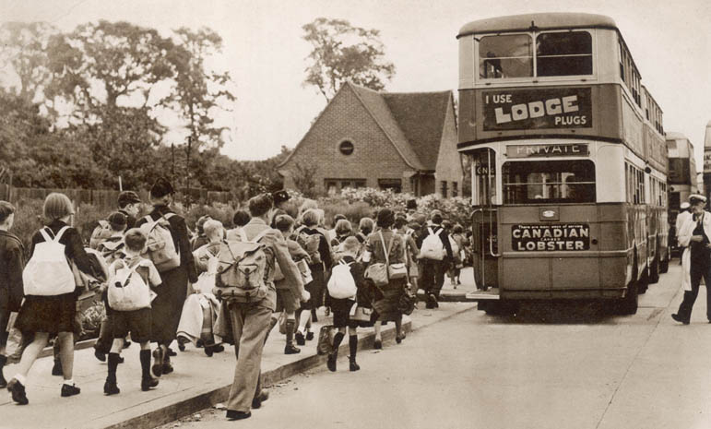

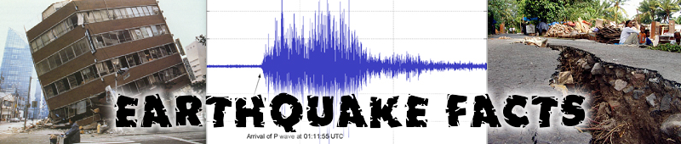
Several million earthquakes occur in the world each year. However, many of these are undetected because they occur in remote areas or are very weak. On average, there are 18 major earthquakes and one great earthquake each year. Earthquakes are the deadliest of all natural disasters. Most deaths are caused by collapsing buildings or fires, or if the earthquake triggers a tsunami. (1)
The Great San Francisco Earthquake of 1906
Founded in 1776, San Francisco remained a small town until gold was discovered in California in 1848. As the gold miners' supply station, San Francisco became a boom town. By 1906 it was one of the nation's major cities with a half-million people. Its location near several of California's many faults, including the San Andreas Fault, made San Francisco prone to earthquakes. Quakes shook the region in 1838. But no one was prepared for what happened in the spring of 1906. (2)
At 5:12 am, on April 18, underground rocks broke along the San Andreas Fault just ten miles from San Francisco. A loud roar could be heard as the earth shook for a minute, toppling buildings. Within 15 minutes, dozens of fires were raging in downtown San Francisco. The fires burned for three days and were so intense that reddish smoke was visible to ships 100 miles out at sea. (3)
The quake and fires destroyed much of San Francisco. Half the city's residents lost their homes. Many survivors fled San Francisco and never returned, making an accurate casualty count impossible. Although the death toll from the Great San Francisco Earthquake and Fire is often placed at 700, some historians insist that more than 3,000 people died in this disaster. (4)

Japan's Great Earthquake of 1923

Japan, which lies in the boundary of two of the Earth’s great tectonic plates, has been struck by many earthquakes. The country has even been called the world's earthquake factory. On September 1, 1923, at two minutes before noon, a tremendous quake shook Japan's Sagami Bay region. (5)

Many people in Japan had been cooking their noontime meal when Great Kantō earthquake struck. As buildings in Tokyo and Yokohama toppled, stoves overturned. Fires ignited and grew so large that they generated their own winds, created what are called firestorms. In Tokyo, more than 40,000 people sought safety in an open park known as the Military Clothing Depot. Nearby buildings caught fire, launching a firestorm that swept through the crowd like a flaming hurricane at 150 miles per hour. At least 38,000 of the people, men, women and children, perished as flame swept through the park. (6)

Fires, toppling buildings, and tsunamis claimed up to 150,000 lives. Roughly half of Tokyo and most of Yokohama were destroyed by the Great Earthquake of 1923. Because of the extensive damage to Tokyo's telephone and telegraph wires, the city turned to an unusual means of communication. For a week after the earthquake, messages were sent out of Tokyo by 400 specifically trained carrier pigeons. (7)

Peru's Earthquake of 1970
At 3:23 pm., on May 31, 1970, an earthquake jolted the South American country of Peru. Enormous damage occurred in Peru's coastal department of Ancash. In the city of Huaraz, as many as 20,000 people died in the crumbling buildings. Chimbote and other towns in the area were also greatly damaged or destroyed. The quake's focus was 15 miles off the coast of Peru, far below the Pacific Ocean seafloor. Due to the great depth of its point of origin, the quake did not disturb the seabed, so no major tsunamis occurred. But while it produced no killers from the ocean depths, the quake triggered some deadly events from the heights of Peru. (8)
The quake shook loose a huge mass of material from Huascaran, the 22,205-foot mountain that is Peru's highest peak, unleashing a combination avalanche-landslide. Millions of tons of snow, ice, rocks, and mud shot down the mountain's slopes at speeds sometimes exceeding 150 miles per hour, burying thousands of people alive. Elsewhere the half-mile-wide mass of debris flattened villages and farms like a giant bulldozer. When it finally ended, the Peruvian quake and accompanying landslide-avalanche had claimed nearly 80,000 lives and had destroyed the homes of nearly a million people. It is the deadliest natural disaster ever to strike North or South America. (9)

Questions: Your teacher will ask you questions about each paragraph which need short, informative answers. Then you should try to answer the following questions which require responses that need a bit more thought.

1. What causes most deaths during an earthquake? (1) 2 marks

2. What is dangerous about the location of San Francisco? (2) 2 marks

3. What evidence shows how intense the fire was? (3) 1 mark

4. Why was it not possible to do an accurate count of the victims? (4) 1 mark

5. Why has Japan been called the ‘world’s earthquake factory’? (5) 1 mark

6. Explain how a ‘firestorm’ is created? (6) 1 mark

7. Why were carrier pigeons used in Tokyo following the earthquake? (7) 1 mark

8. Why were no major tsunamis caused during the Peru earthquake? (8) 1 mark

9. Why were so many people buried alive during the earthquake? (9) 1 mark

10. What precautions do you think can be taken about earthquakes nowadays? 3 marks

VOLCANOES

There are about 1,500 active volcanoes, with 50 or so erupting each year. Most of these volcanoes are found around the Pacific Ocean – a belt known as the Pacific ‘Ring of Fire’. Europe has its own volcanoes, such as Etna and Vesuvius, that have erupted many times in history. (1)

At least 500 million people live close to an active volcano. When an eruption occurs, nearby areas may be covered with ash and red-hot lava. Fields and buildings may be buried. Poisonous gases, clouds of glowing ash or mud flows may kill everyone in their path. Fortunately, satellites are now helping to identify the most dangerous volcanoes. Such data saves lives and helps to predict when the next eruption will come. Satellite maps of the damaged areas also help rescue and recovery. (2)

Death of a City

There were, of course, no satellites to predict the destruction of the Roman city of Pompeii when the volcano named Vesuvius literally blew its top on August 24, 79AD. spewing tons of molten ash, pumice and sulfuric gas miles into the atmosphere. A ‘firestorm’ of poisons vapours and molten ash poured down on the surrounding area suffocating the inhabitants of the resort cities of Pompeii, Herculaneum and Stabaie. Tons of falling debris filled the streets until nothing remained to be seen of these once thriving communities. The cities remained buried and undiscovered for almost 1700 years until excavation began in 1748; these excavations continue today and provide us with insights to life in the Roman Empire. (3)
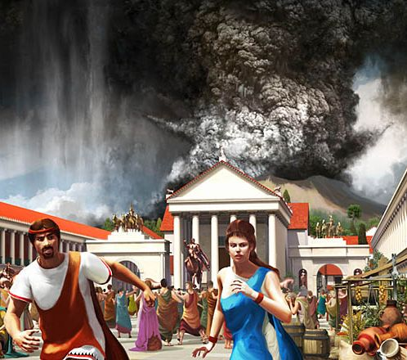
A Witness from the Past
In this letter, a young Roman, named Pliny, describes what happened to him and his mother during the second day of the disaster. (4)
Ashes were already falling, not as yet very thickly. I looked round: a dense black cloud was coming up behind us, spreading over the earth like a flood. (5)
“Let us leave the road while we can still see,” I said, “or we shall be knocked down and trampled underfoot in the dark by the crowd behind.”' We had scarcely sat down to rest when darkness fell, not the dark of a moonless or cloudy night, but as if the lamp had been put out in a closed room. (6)
You could hear the shrieks of women, the wailing of infants, and the shouting of men; some were calling their parents, others their children or their wives, trying to recognize them by their voices. People bewailed their own fate or that of their relatives, and there were some who prayed for death in their terror of dying. Many besought the aid of the gods, but still more imagined there were no gods left, and that the universe was plunged into eternal darkness for evermore. (7)
A gleam of light returned, but we took this to be a warning of the approaching flames rather than daylight. However, the flames remained some distance off; then darkness came on once more and ashes began to fall again, this time in heavy showers. We rose from time to time and shook them off, otherwise we should have been buried and crushed beneath their weight. (8)
Pliny and his mother were amongst the lucky few to escape by boat from the dying city of Pompeii. Most people were suffocated, buried under metres of volcanic ash, where they lay for hundreds of years until excavation began in modern times. (9)

Questions: Your teacher will ask you questions about each paragraph which need short, informative answers. Then you should try to answer the following questions which require responses that need a bit more thought.

1. What is the Pacific ‘Ring of Fire’? (1) 1 mark

2. What are the most dangerous products of an eruption? (2) 2 marks

3. Why are satellites so useful? (2) 1 mark

4. How were most people killed during the Vesuvius eruption? (3) 2 marks

5. Why were the cities not discovered for so long? (3) 1 mark

6. Why did Pliny say they should try to escape right away? (6) 1 mark

7. What evidence is there that people were terrified? (7) 3 marks

8. What did Pliny realise the ‘gleam of light’ actually was? (8) 1 mark

9. Why were Pliny and his mother among the fortunate few? (9) 1 mark

10. Would you like to visit the city of Pompeii now that it has been

been excavated? Give reasons for your response. 2 marks

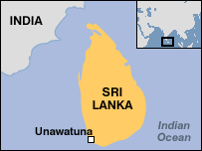
A CHRISTMAS TSUNAMI
The earthquake that generated the great Indian Ocean tsunami of 2004 is estimated to have released the energy of 23,000 Hiroshima-type atomic bombs. Giant forces that had been building up deep in the Earth for hundreds of years were released suddenly on December 26, shaking the ground violently and unleashing a series of killer waves that sped across the Indian Ocean at the speed of a jet airliner. (1)
The epicenter of the 9.0 magnitude quake was under the Indian Ocean near the west coast of the Indonesian island of Sumatra. The violent movement of sections of the Earth's crust, known as tectonic plates, displaced an enormous amount of water, sending powerful shock waves in every direction. (2)
The Indian Ocean tsunami traveled as much as 3,000 miles (nearly 5,000 kilometers) to Africa, arriving with sufficient force to kill people and destroy property. By the end of the day more than 150,000 people were dead or missing and millions more were homeless in 11 countries, making it perhaps the most destructive tsunami in history. (3)
An Eyewitness Account
Here is part of an account given by BBC newsman Roland Buerk who happened to be in the town of Unawatuna in Sri Lanka when the great tsunami of Boxing Day 2004. (4)
We didn't feel the earthquake here so there was no warning at all. Then at about 10.00 this morning our time a huge wave suddenly hit the beach. We were still in bed in a ground floor room right on the beachfront when we suddenly heard some shouts from outside. Then the water started coming under the door. Within a few seconds it was touching the window. (5)
We very quickly scrambled to get out as the windows started to cave in and glass shattered everywhere. We swam out of the room neck deep in water, forcing our way through the tables and chairs in the restaurant and up into a tree. But within about 30 seconds that tree collapsed as well and we were thrust back into the water where we had to try and keep our heads above the water line. We were swept along for a few hundred metres, trying to dodge the motorcycles, refrigerators, cars and other debris that were coming with us. Finally, about 300m inshore, we managed to get hold of a pillar, which we held onto until the waters just gradually began to subside. (6)
Other people though weren't so lucky. (7)
One elderly British gentleman was walking around in a state of shock. His wife had been swimming when the waves struck. A family walked past carrying a very small bundle with pale white feet poking out the bottom of it. As they walked past, their teenage son, wearing an England football shirt said in a very matter of fact way “My little brother is dead”. (8)
Looking around it's easy to see that this has caused incredible devastation here. There are cars in trees, buildings destroyed. I certainly haven’t been inside the ruins of the hotel or other buildings, or joined in the digging yet. And it’s impossible to get an accurate picture of the number of casualties from where I am. But in one small area of one small village I’ve seen four bodies so far, two Sri Lankans – and elderly lady and a young woman – and the Western boy who looked to be about five years old. (9)
There are no kind of emergency services here, there are no helicopters thumping through the sky to come to save people. It is a do-it-yourself rescue. People are trying to get into collapsed buildings to search for those who might be trapped – the dead can come later. (10)

Questions: Your teacher will ask you questions about each paragraph which need short, informative answers. Then you should try to answer the following questions which require responses that need a bit more thought.

1. What evidence tells us how powerful the tsunami was? (1) 1 mark

2. What caused the powerful shock waves that triggered

the tsunami? (2) 1 mark

3. Why has this tsunami been called

‘the most destructive tsunami in history’? (3) 2 marks

4. What is an ‘eyewitness account’? (4) 1 mark

5. What evidence tells us the water rose very rapidly? (5) 1 mark

6. How did Buerk and his family manage to save their lives? (6) 2 marks

7. Why is paragraph (7) given a single line? (7) 1 mark

8. Why is paragraph (8) so sad? (8) 2 marks

9. Describe the ‘incredible devastation’ in your own words. (9) 2 marks

10. Explain the meaning of “It is a do-it-yourself rescue.” (10) 2 marks

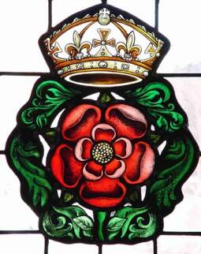
DAILY LIFE IN TUDOR TIMES
Tim Lambert
http://www.localhistories.org/tudor.html

The Tudors were a Welsh-English family who ruled England and Wales from 1485 to 1603 (118 years). The Tudor monarchs were: Henry VII, Henry VIII, Edward VI, Jane Grey, Mary I, and Elizabeth II. Poor Jane Grey only ruled for 9 days before Mary I had her arrested and later executed. The symbol of the Tudors was the Tudor Rose.
TUDOR ENGLAND
In Tudor England most of the population lived in small villages and made their living from farming. However, towns grew larger and more important. During the 16th century trade and industry grew rapidly and England became a more and more commercial country. Mining of coal, tin and lead flourished. So did the iron industry. During this period England became richer and richer. (1)
In the 15th century the population of England may have been around 2 1/2 million. It rose steadily during the 16th century. By 1525 it had risen to around 3 million and by 1600 it was about 4 million. (2)
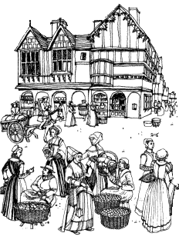
TUDOR SOCIETY
Tudor society was divided into four broad groups. At the top were the nobility who owned huge amounts of land. Below them were the gentry and rich merchants. Gentlemen owned large amounts of land and they were usually educated and had a family coat of arms. Most important gentlemen never did any manual work - that was beneath their dignity! Below the gentry were yeomen and craftsmen. Yeomen owned their own land. They could be as wealthy as gentlemen but they worked alongside their men. Yeomen and craftsmen were often able to read and write. Below the yeomen were the tenant farmers who rented their land from the rich. There were also wage labourers. They were often illiterate and very poor. (3)
In the 16th century about 50% of the population lived at subsistence level. In other words they had just enough food, clothes and shelter to survive. For them life was very hard. However it was possible to move from one class to another. A yeoman could buy a coat of arms and become a gentleman, if he could afford it. In this way, it was possible for an ambitious young man to rise in the world. (4)
In the 16th century the power of the monarchy increased. During the Middle Ages the barons held castles, which were very difficult to capture so it was easy for them to rebel. Cannons changed all that. (Guns were invented in the 14th century and they gradually became more efficient). (5)
THE POOR IN TUDOR ENGLAND
With the rise in population during the 16th century jobs were not always easy to find. In Tudor times there were thousands of people without jobs wandering around looking for work. There were also disabled beggars. There were also people who pretended to be mad or disabled in order to beg. Tudor governments tolerated people who were disabled begging. However they did not tolerate able-bodied people without jobs wandering around. They saw such 'sturdy vagabonds' as a threat to law and order. They were treated very harshly. (6)
Since the 14th century there had been laws against vagabonds but in 1530 a new law was passed. The old and disabled poor were to be given licences to beg. However anyone roaming without a job was tied to a cart in the nearest market town and whipped till they were bloody. They were then forced to return to the parish where they had been born or where they had lived for the last 3 years. (7)
A law of 1536 was more severe. Vagabonds were whipped the first time. However for a second offence they part of their right ear was cut off (so they could be easily identified wherever they went). For a third offence they were hanged. However officers of the law were reluctant to carry out such terrible punishments. A law of 1547 chided them for 'foolish pity and mercy'. This terrible law was abolished in 1550. Once again flogging was made the punishment for vagrancy – wandering around the countryside without looking for work. (8)
Furthermore every parish was commanded to build a workhouse for the old and disabled poor. They would be housed in the workhouse and made to do any work they were capable of. However in 1572 the law was made more severe again. For a first offence a vagabond would be whipped and burned in the right ear with a red-hot iron. (Unless some kindly employer was willing to give him a job). For a second offence he would be hanged (again unless an employer gave him a job). For a third offence he would be hanged regardless. (9)
In 1576 the law regarding the old and disabled was changed again. This time the parishes were ordered to supply them with materials like flax, hemp, wool and iron. They were to do any work they could in their own homes. Any old or disabled person who refused to work was sent to a House of Correction where conditions were very harsh. However, in 1597 the death penalty for being a vagabond was abolished in England. (10)
Questions about Tudor England
1. In Tudor times, did most people live in the countryside or in towns? (1) (1)
2. List 4 industries that became very successful in the 16th century? (1) (4)
3. Why do you think the population of England grew so quickly
in the 16th century? (2) (2)
4. Who owned most of the land in Tudor times? (3) (1)
5. What did the noble families have to show they were important? (3) (1)
6. Explain the difference between yeomen farmers and tenant farmers? (3) (2)
7. What do we call poor people who worked only for wages? (3) (1)
8. What does it mean if a family are living at ‘subsistence level’? (4) (2)
9. What did many young ambitious men want to do? (4) (2)
10. Explain why barons lost so much of their power in the 16th century. (5) (3)

11. Why was work difficult to find in Tudor times? (6) (2)
12. How did Tudor governments treat beggars who were really disabled? (6) (1)
13. Who were the ‘sturdy vagabonds’? (6) (1)
14. What important changes to the law took place in 1530? (7) (3)
15. List the three severe punishments that were introduced in 1536? (8) (3)
16. Why were workhouses built in every parish? (9) (2)
17. How could a vagabond be saved from a terrible punishment? (9) (1)
18. Explain why a vagabond might be hanged? (9) (2)
19. What importance change was made to the law in 1576? (10) (1)
20. Why do you think the death penalty for being a vagabond was finally
abolished in 1597? (10) (2)
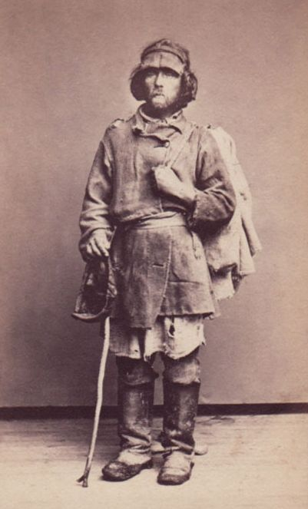

This is what a Tudor vagabond looked like in the 16th century.
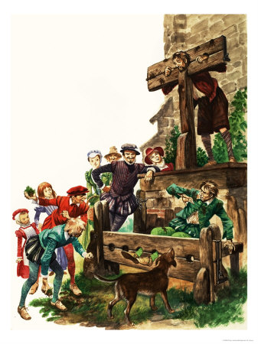
TUDOR PUNISHMENTS
Tudor punishments were simple but harsh. In the 16th century minor crimes were often punished by the pillory or the stocks. The pillory was a wooden frame on a pole with holes through which a person's head and hands were placed. The frame was then locked and the person was subjected to humiliation and ridicule. The stocks was a wooden frame with holes through which a person's feet were placed and they were humiliated in the same way. Other common punishments were flogging and branding with red hot irons. (1)
More serious crimes were punished by death. Beheading was reserved for the wealthy. Ordinary people were usually hanged. (They were suspended with a rope round their neck until they were strangled to death). However there were worse ways of killing people. (2)
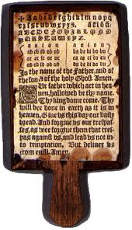
In Tudor England the punishment for treason was hanging, drawing and quartering. The person was drawn on a hurdle pulled by a horse to the place of execution. They were hanged (strangled by being suspended by a rope) but when they were still alive and sometimes conscious they were cut down. The executioner cut open their stomach and 'drew out' their entrails. Finally the person was beheaded and his body was cut into quarters. (3)
TUDOR EDUCATION
Boys usually went to a kind of nursery school called a 'petty school' first then moved onto grammar school when they were about seven. The school day began at 6 am in summer and 7 am in winter (people went to bed early and got up early in those days). Lunch was from 11 am to 1 pm. School finished at about 5pm. Boys went to school 6 days a week and there were few holidays. (4)
Many children learned to read and write with something called a hornbook. It was not a book in the modern sense. Instead it was a wooden board with a handle. Fixed to the board was a sheet of paper with the alphabet and the Lord's Prayer (the Our Father) written on it. The paper was usually protected by a thin slice of animal horn. (5)
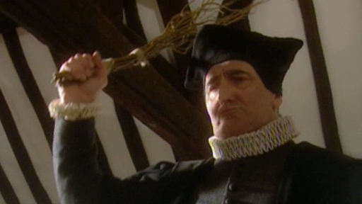
Discipline in Tudor schools was savage. The teacher often had a stick with birch twigs attached to it. Boys were hit with the birch twigs on their bare buttocks. At about 15 or 16 the brightest boys might go to one of England's two universities, Oxford and Cambridge. Many boys did not go to school at all. If they were lucky they might get a 7-year apprenticeship and learn a trade. Some craftsmen could read and write but few labourers could. (6)
As for girls, in a rich family a tutor usually taught them at home. In a middle class family their mother might teach them. Upper class and middle class women were educated. However lower class girls were not. Children from rich families usually had their marriages arranged for them. If they refused to marry the person their parents chose they were beaten until they changed their minds. Children from poorer families had more choice over whom to marry. Yet girls usually married young. Many were married when they were only 15 or 16. Boys often married between the ages of 18 and 21. (7)
Tudor children who did not go to school were expected to work. They helped their parents by doing tasks such as scaring birds when seeds were sown. They also helped to weave wool and did other household tasks. (8)
Questions about punishments and education in Tudor times

1. How did people humiliate the wretches in the pillory or the stocks? (1) (3)
2. Name two other punishments that were often used. (1) (2)
3. Why do you think wealthy people were beheaded rather than hanged? (2) (2)
4. What do you think was the worst part of being hanged, drawn and quartered? (3) (2)
5. Do you think the school days were too long for Tudor boys?
Give reasons for your answer? (4) (3)
6. Explain how pupils used a ‘hornbook’ in their lessons. (5) (3)
7. In your opinion, was punishment too harsh in Tudor schools?
Give reasons for your answer. (6) (3)
8. What happened to girls who refused to accept an arranged marriage? (7) (2)
9. Why do you think people married so young in Tudor times? (7) (2)
10. Describe the ways in which poorer children helped at home. (8) (2)


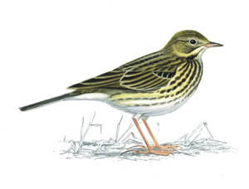
The Meadow Pipit - A Tudor Story

Adam listened carefully to the sound of the little brown meadow pipit trilling out its Spring song. He picked up his little wooden flute and tried to copy the joyful sounds the bird was making. Ever since his father had given him the home-made flute, he loved sitting out on the soft moorland grass trying to copy the bird’s song as the sheep safely grazed. He hadn’t got it quite right yet, but he knew he would in the end; although a very gentle boy Adam was also a determined one. (1)

Lambs, like little white clouds, danced around the ewes who tolerated the frolics of the young as only mothers can. Adam smiled affectionately at the small family closest to him – two ewes, one ram, four lambs. There were around one hundred sheep in the flock but only this small group belonged to his family; the rest were the property of the nearby Abbey for whom Adam’s father, Jacob, was employed as shepherd. The monks of the Abbey were as rich as his family were poor, but Adam doubted they were as happy as his. (2)

The boy suddenly caught the sound of dogs barking a way off and he jumped to his feet, calling the huge sheepdog he had with him to heel. The wolves that still roamed the hills were probably far away now, raising their young in the crags where people wouldn’t hunt them down, but you could never be too sure. He stood ready to defend his flock against whoever might be coming, but within a few minutes he was relieved to see Brother Robert riding hard on one of the Abbey’s finest horses though he was less pleased by the way sheep panicked and scattered across the moor. (3)

“Boy!” cried the monk, “Do your job. Get those sheep rounded up – all of them. Get them down to the Abbey. The King’s men are here. They need to count them. ‘Good’ King Henry wishes to know ‘his’ wealth. Make haste. It does not pay to keep ‘Good’ King Henry waiting.” Brother Robert whirled his steed and pounded down the track, careless again of the effect he was having on the silly sheep. (4)

Adam’s mind was racing. Had it finally happened? There had been an agony of waiting hereabouts since the King had declared his break with the Church and the Pope. Henry had turned his greedy eyes on the great abbeys that owned land as far as the eye could see on the Moor. The boy knew that his father was worried about what was going to happen to the family’s house since it belonged to the Abbey and of course whether he could continue to work as a shepherd. It had never occurred to anyone that they might lose their own sheep as well. And then what would they have? Nothing but the clothes on their backs. They would be vagabonds, vagrants, nothing. (5)

As he drove the sheep down to the Abbey, he stopped at St Anne’s Well, a holy spring with a good reputation for granting wishes. He wondered if a Catholic Saint would still look kindly on a country where the Pope was no longer welcome. He wasn’t sure, but knelt down, crossed himself and said a quick prayer anyway. Only a few minutes later, his father arrived, and Adam knew by the frown on his face that matters were serious. He greeted his father but said nothing more. Adam loved his father dearly and would nothing to add to his worries. (6)

“Come now, Adam, we must get down to the Abbey as quickly as we can. King Henry has confiscated the abbey. His men, the clerks, are here to make a record of what belongs to the king – and that means everything, even our little flock. Whatever happens it is God’s will as well as the king’s, and we will obey and make the best of it.” (7)

Again Adam said nothing, but slipping the little wooden flute from his tunic he began to play the song of the meadow pipit. He found it easy. Every note was in the right place. A pipit itself could not have done better. His father smiled, ruffled his son’s thick corn-coloured hair, and said, “I am a fortunate father to have a son like you.” Adam looked up and smiled, “But I am more fortunate to have a father like you.” (8)

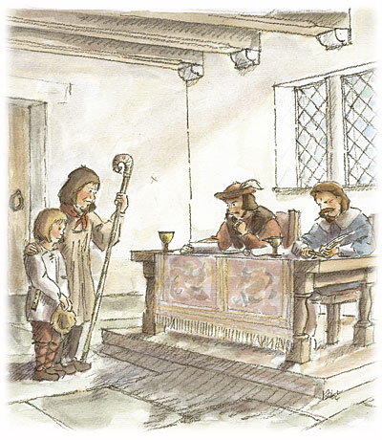
“You have answered our questions well,” said the Chief Clerk, twirling a quill between his inky figures. “Brother Robert swears you are an honest man. Be as honest for King Henry as you have been for the monks – all of whom you know must leave the Abbey before the summer solstice. You are to be shepherd to the king. You will remain in your home. You will select twelve ewes, sixteen lambs, and three sturdy rams. The king is a generous man, but do not ask for further payment this year. There are limits to his generosity. Now go… but wait a moment. We have had a long and tiresome day. Can your boy play that flute? We would have some entertainment before you go.” (9)

Late autumn. The lambs were grown; they now stood as patiently as their mothers. Adam sat in the grass, his back against Bruno who snored peacefully to himself. Adam played the song of the meadow pipit once again. But this time he played it for St. Anne. (10)

Answer your teacher’s questions.

READING COMPREHENSION IN SATS KEY STAGE 2
Questions indicate the maximum number of marks that can be awarded for an answer. Sometimes the questions will involve multiple choice answers, or children will be required to complete a table, match up statements or label names of the features of a text. A range of questions will assess the child’s ability to:
RETRIEVE information.
What was Dan’s mum making for dinner?
INFER information about a theme or characters based on what they have read.
How does Matthew feel about eating cottage pie and peas? How do you know?

Make DEDUCTIONS, where children have to draw their own conclusions using reasoning skills. What do you think Dan might do next? Explain why you think this.

Express OPINIONS.
Do you think Dan’s mum is a kind person?
Use evidence from the text to support your answer.

Comment on the EFFECTIVENES OF LANGUAGE
‘Dan thought practising spellings was a bit like watching paint dry.’
Why is this a good way to show how Dan feels about his spellings?

1. Look at ………. . Find the word that means the same as ………… .
2. How does the picture on …………….. help you understand……….. ?
3. Find and copy what X says when……………………………………..
4. Explain how the picture helps us understand what is going on in the story.
5. How does the author make X seem……. special/selfish/kind?
6. Find two pieces of evidence that show……………………………….
7. Complete the thought bubble to show………………………………..
8. What did X learn in this story? Explain fully.
9. How does the style of the language used in A differ from the style used in B?
10. Which of the following statements are True, and which are False?
11. Why has the author included quotations in this text?
12. What do you think X wrote in reply to Y’s letter? Write it here.
13. Why do you think X’s attitude towards Y changed?
14. How do we know that………………………………………….?
15. Find one thing that is intended to be humorous. Why is it humorous?
16. Why do you think the Author has used humour at this point?
17. Which part of the text expresses opinions and which part states facts?
18. Where and when did this story take place? Give evidence.
19. Can you think of a subheading for each paragraph?
20. From whose viewpoint is this story told (or being told)?
GUIDANCE ON USING THESE TEXTS

- The focus should be on reading comprehension. Although the teacher may use the texts to elicit responses, in general these should not be required until pupils have engaged thoroughly with a text for reading.

- Differentiation is the key to guided reading activities. This is the key to working with groups of mixed ability. In general, the teacher should work through the paragraphs asking questions that require short, informative responses. Quick-fire question to elicit quick-fire answers. These questions must be differentiated so that less-able pupils have the opportunity to contribute as much, if not more so, than more able pupils.

- Teachers must resist the temptation to believe that less-able pupils are learning from more able pupils. In general, they are not, principally because the speeds of thought and assimilation can be radically different. The key is to keep all of the pupils involved by differentiation that provides incentives for all, or most, pupils to remain involved.

- Teachers must resist the temptation to over-explain, or even to explain. Pupils will stay involved as long as they are comfortable and challenged within reason. If the teacher insists on explaining too much, pupils will withdraw on the grounds (reasonable) that the teacher is going to explain it anyway. Equally, teachers should avoid teacher-echo, or at least keep it to a minimum.

- Teachers should not accept answers which are palpably wrong. Pupils appreciate being told gently/briefly that there response is wrong or inadequate in some way or other. Telling a pupil that 2 + 2 = 5 is ‘not quite right’ is nonsense, and the pupil knows it; and, even if he doesn’t, many of those around him do. In being ‘kind’, the teacher is unconsciously undermining the trust of pupils as a reliable authority concerning knowledge.

- Teachers must make themselves familiar with any text/s they are using for reading comprehension activities. Quick-fire differentiation requires experience and expertise. A teacher can only be in command of the text if he is familiar with its contents. This does not mean the teacher should prepare the questions in advance of the session but they should be so familiar with the text that a quick glance at a paragraph indicates the question that are mostly likely to elicit quick-fire responses. This is particularly important in the opening session of reading comprehension. If the teacher begins by floundering, who can fault the pupils from joining in a general flounder?

- Teachers should also remember the questions themselves form part of the reading.

